Converting between Magnetic and True North bearings

When a compass does not have a declination set:

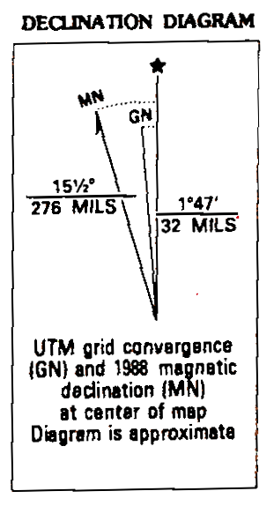
Map to compass – West, Add (true to magnetic)
Bearing measured on map: 45 degrees (true)
Declination 15 degrees West
Map to compass: 45 + 15 = 60 degrees (magnetic)

Compass to map – West, Subtract (magnetic to true)
Bearing measured with Compass: 45 degrees (magnetic)
Declination 15 degrees West
Compass to map: 45 - 15 = 30 degrees (true)

Map to compass – East, Subtract (true to magnetic)
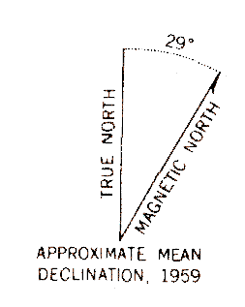
Bearing measured on map: 45 degrees (true)
Declination 15 degrees East
Map to compass: 45 - 15 = 30 degrees (magnetic)

Compass to map – East, Add (magnetic to true)
Bearing measured with Compass: 45 degrees (magnetic)
Declination 15 degrees East
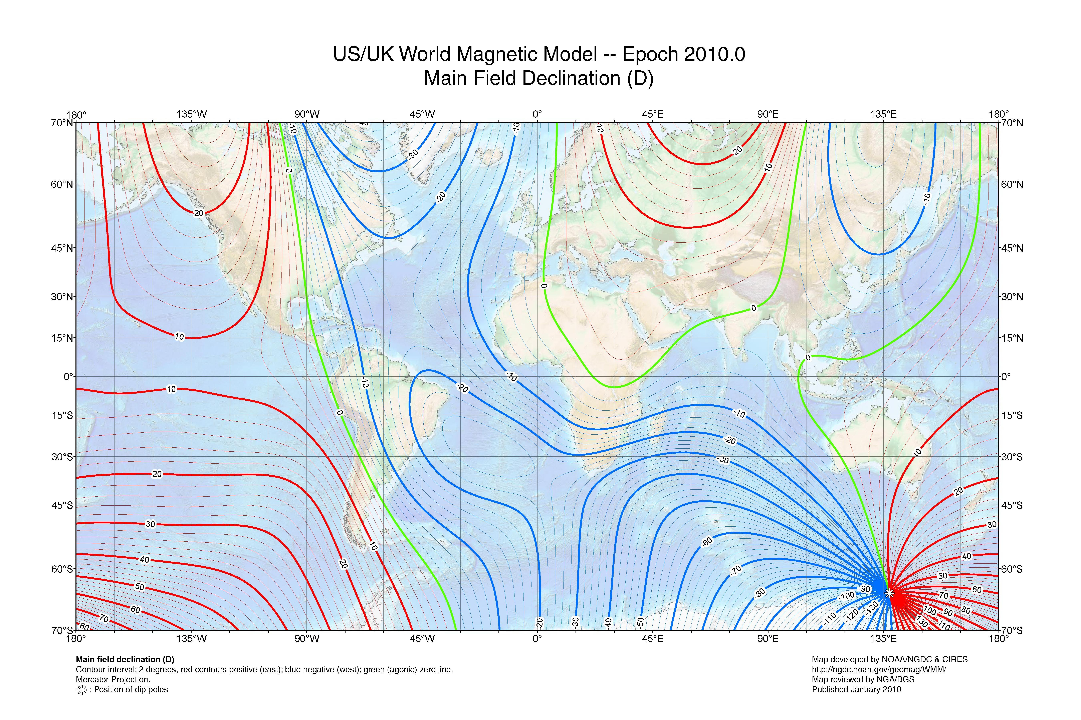
Compass to map: 45 + 15 = 60 degrees (true)

